CCT360H5: WEB DEVELOPMENT AND DESIGN II
Lab5 - Sample Midterm Exam Simulation (90-Minute Timed Practice)
Time Limit Target: 90 Minutes | Format: In-Class Practical Exam | Submission: Zipped Project Folder (.zip)
1. Exam Instructions & Submission Rules
- Exam Format: You have 90 minutes to construct a responsive Admin Dashboard Portal from scratch using PURE HTML5 and CUSTOM CSS.
- No Frameworks Allowed: Bootstrap, external CSS libraries are strictly prohibited.
- Asset Folder Provided: Use the provided assets/ folder containing image files (logos/logo.jpg, avatar/(man or woman).jpg, images/(project1.jpg, project2.jpg)) for your markup.
- Submission Packaging: When finished, compress your entire project folder (containing index.html, style.css, and assets/) into a single ZIP archive (e.g., student_id_lab5.zip) and upload directly to Quercus. Do NOT submit GitHub links for this sample exam.
- Note: Before you submit unzip(extract package), double click the index.html and verify the layout and design works
2. Target Layout Blueprint (Admin Dashboard)
Your page structure and layout flow must match the ASCII blueprint below:
+---------------------------------------------------------------------------------------+
| <header class="dash-header"> |
| [ Logo Image: assets/logo.png ] [ Search Input ] [ Avatar Image: assets/avatar.jpg ] |
+---------------------------------------------------------------------------------------+
| <div class="dash-wrapper"> |
| +---------------------+ +-----------------------------------------------------------+ |
| | <aside class="sidebar">| | <main class="dash-content"> | |
| | | | | |
| | - Dashboard | | <section class="stats-grid"> | |
| | - Analytics | | +---------+ +---------+ +---------+ +---------+ | |
| | - Projects | | | Metric 1| | Metric 2| | Metric 3| | Metric 4| | |
| | - Settings | | +---------+ +---------+ +---------+ +---------+ | |
| | | | | |
| | [ Logout Link ] | | <section class="body-split"> | |
| +---------------------+ | +---------------------------+ +---------------------+ | |
| | | Project Showcase (Table) | | Recent Activity | | |
| | | - assets/project1.jpg | | - Audit Log Feed | | |
| | | - assets/project2.jpg | | | | |
| | +---------------------------+ +---------------------+ | |
| | </main> | |
+---------------------------------------------------------------------------------------+
| <footer class="dash-footer"> |
| [ (c) 2026 CCT360 Analytics Portal - Midterm Exam ] |
+---------------------------------------------------------------------------------------+
3. Layout Requirements & Structural Guidance
You are expected to choose appropriate layout models (CSS Grid or Flexbox) based on the structural requirements below:
- Header Section: Align the brand logo (assets/logo.png), search bar, and user profile avatar (assets/avatar.jpg) in a horizontal row. The logo and avatar must maintain exact image dimensions and stay vertically centered.
- Macro App Wrapper: Structure the main area so that a sidebar navigation panel (fixed width around 250px–280px) sits alongside the primary dashboard content area on desktop views.
- Sidebar Navigation: Arrange navigation links vertically in the sidebar. The Logout link must be pinned to the bottom of the sidebar area regardless of screen height.
- Metric Cards Row: Display 4 statistical cards in an equal-width horizontal row across the top of the main dashboard section on desktop screens.

Statistical Cards Content Direction
Inside the <section class="stats-grid"> section, construct 4 individual metric cards representing key analytics for the dashboard. Each card must include:
- Category Label: A brief title describing the metric (e.g., Total Users, Monthly Revenue, Active Projects, Completion Rate).
- Key Metric Value: A bold, prominent number or value (e.g., 1,248, $14,850, 34, 94.2%).
- Trend / Secondary Line: A small indicator or context line below the value (e.g., +12% this month, 6 closing this week).

- Main Data & Activity Split: Divide the lower main content area into an asymmetric 2-column split (approx. 2:1 ratio) displaying a project showcase table/grid (featuring assets/project1.jpg and assets/project2.jpg) next to a recent activity feed.

Activity Feed
Inside the recent activity feed, include 4–5 chronological event items—each displaying a User Name, a short Action Description (e.g., "Sarah Chen updated project settings"), and a Timestamp (e.g., "2 mins ago"), stacked vertically in a clean single-column list.
- Mobile Responsiveness (<768px): Apply a media query so that on mobile screens, the macro layout, metric cards, and lower split section all collapse into a clean single-column vertical stack.
4. Grading Rubric Breakdown (10 Points Total)
Component | Evaluation Criteria | Weight
Macro & Multi-Column Layouts | Correct implementation of sidebar split, 4-card metric section, and asymmetric content split on desktop. | 3 pts
Flexbox & Component Mechanics | Header alignment, image integration/sizing, vertical sidebar navigation, and bottom link pinning. | 3 pts
Mobile Responsiveness | Clean vertical single-column collapse under 768px viewports without horizontal scrollbars. | 2 pts
Code Standards & Packaging | Semantic HTML5 markup, zero framework usage, clean file structure, and valid ZIP submission. | 2 pts

Desktop View
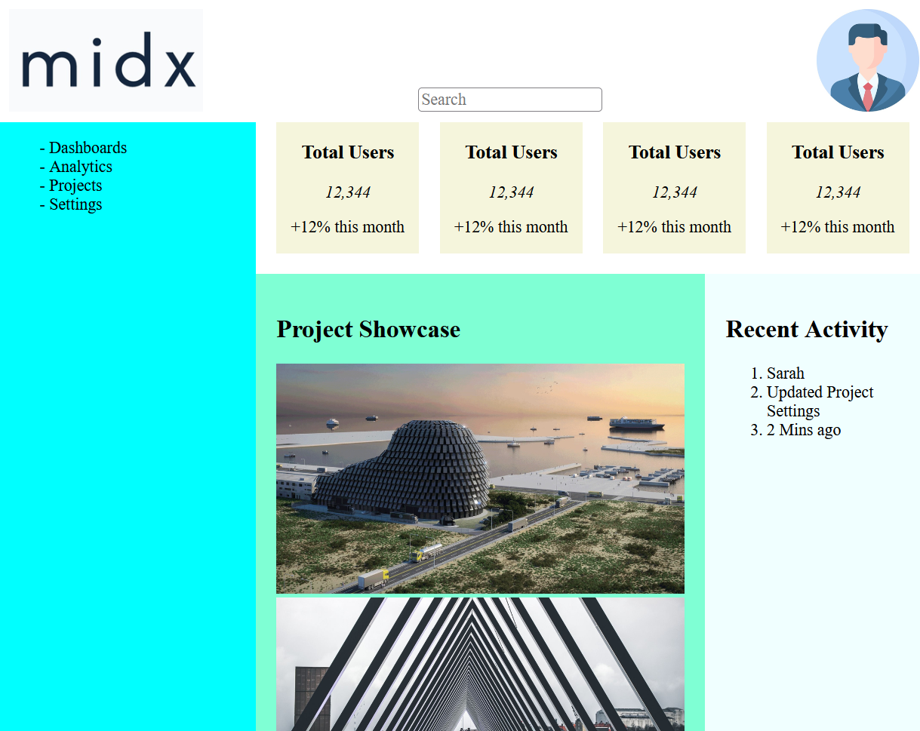

Mobile View
